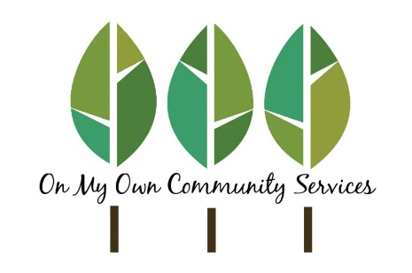
TO: All Employees
FROM: Michelle Ramirez, CEO
RE: Public Health Order on COVID-19 Mandatory Vaccinations
DATE: October 1, 2021

On September 28, 2021, the California Department of Public Health issued a new public health order instituting a COVID-19 vaccine mandate. This order includes all employees of On My Own Community Services. In order to comply with this order, On My Own Community Services will implement the following measures effective immediately.
All employees must be fully vaccinated (including the second dose of a two-dose regimen) by November 30, 2021.
An employee may request an exemption from this requirement only upon providing a completed COVID Vaccination Exemption Request form signed by the employee stating either of the following:
- Employee is declining the vaccination based on sincerely held religious beliefs
- Employee is excused from receiving the vaccine due to qualifying medical reasons. To be eligible for a medical exemption, the employee must also provide a written statement signed by a licensed medical professional stating the employee qualifies for the exemption. The employee may use the COVID Vaccination Healthcare Provider Supporting Statement form for this purpose.
The COVID Vaccination Exemption Request and Healthcare Provider Supporting Statement forms available from the Human Resources Department or for download from eRSP or the OMO Employee Portal.
If an employee is deemed to have met the requirements of an exemption, the unvaccinated employee must meet the following requirements:
- Weekly testing for COVID-19 following authorized protocol at that time.
- Wearing of a company approved surgical mask or higher-level respirator (such as an N95) at all times while inside the workplace, client’s home, or any other indoor location.

This new health order requires On My Own Community Services to maintain records of employees’ vaccination or exemption status consistent with applicable privacy laws and regulations. On My Own Independent Living Services has created a confidential email and cell phone line for this purpose.
Employees who are already fully vaccinated or have received the first of a two-dose regimen are strongly encouraged to submit an electronic copy of their COVID-19 Vaccination Record Card as soon as possible—even if the employee has submitted documentation previously—as we must verify we have the employee’s most current COVID-19 Vaccination Record.
Confidential Email: covid@onmyown-web.com
Confidential Phone Line (Text): 916-225-1840
Any employee who prefers to provide this information in person may contact the Human Resources Department at 916-726-0792 x 122 to make arrangements to do so. The vaccination record will be recorded and stored in the employee’s confidential employment file in the Human Resources Department in accordance with company policy.
All employees must provide a copy of their vaccination record or approved exemption request form no later than November 30, 2021, as this is the deadline for On My Own Community Services to be in full compliance with the new health order.
While I understand not all employees will agree with these new measures, it is necessary for On My Own Community Services to comply with the new health order. These measures will help to safeguard the health of our clients, employees and the community at large from COVID-19, as well as assist in providing a safe workplace for all.
Thank you for your understanding and cooperation.

Michelle Ramirez, CEO

